2016 Amendment to the Tompkins County

Coordinated Public Transit-Human Service Transportation Plan

Report: The ITCTC adopted the Coordinated Public Transit–Human Service Transportation Plan (Coordinated Plan) in October 2007 and has amended the plan annually from 2009-2015 to identify a list of priority projects for funding. The purpose of this amendment is to revise the Plan’s priorities for 2017.

The amendment includes awards of:
- Special Community Mobility Project grants, (which is funded with Section 5307 Urban Formula funds) shown in Table A;
- Mobility Management projects included in the County’s FFY 2017 Section 5307 Urban Formula Grant shown in Table B;
- Capital and Operating Assistance Projects though the Section 5310 Enhanced Mobility for Seniors and Individuals with Disabilities Program shown in Table C.

This amendment is a comprehensive list of projects reviewed and recommended through the Coordinated Transportation Planning program in 2015 which will be implemented in 2017.

Actions Requested: Planning Committee recommendation and Policy Committee approval of the proposed 2016 Amendment to the Tompkins County Coordinated Public Transit–Human Service Transportation Plan to revise the Plan’s priority projects for 2017 as shown in Tables A-C.

Tables A,B & C: Priority Projects for FTA Coordinated Transportation Projects for 2017

Table A
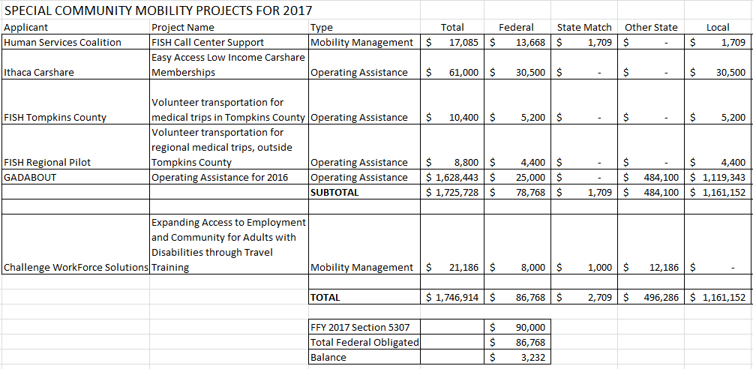

Table B
Mobility Management Projects | Federal  Sec 5307 | NYSDOT | Local | Total
Way2Go/ Tompkins County | $ 220,000 | $ 27,500 | $ 27,500 | $ 275,000
Way2Go/ Regional | $ 130,000 | $ 16,250 | $ 16,250 | $ 162,500
Finger Lakes Rideshare | $ 8,000 | $ 1,000 | $ 1,000 | $ 10,000
Total | $ 358,000 | $ 44,750 | $ 44,750 | $ 447,500

Table C
Section 5310 Enhanced Mobility for Seniors and Individuals with Disabilities
GADABOUT Projects: | Federal  Sec 5310 | State | Gadabout | Total
New Freedom Operating Assistance | $ 41,000 | $ 20,000 | $ 21,000 | $ 82,000
Purchase (2) Buses | $ 86,000 | $ 0 | $ 22,000 | $ 108,000
Total | $127,000 | $20,000 | $43,000 | $190,000

The Policy Committee of the Ithaca-Tompkins County Transportation Council approved this amendment on December 20, 2016.

