Tompkins County, New York

Title VI Program Plan
Update

For 2016-2018

Revised: April 29, 2016

Grantee: 5475

Contents

Tompkins County Title VI Policy Statement 3
Title VI Notice to the Public 4
Title VI Notice to the Public (Chinese) 5
Title VI Complaint Procedures 6
Title VI Investigations, Complaints, and Lawsuits 9
Public Participation Plan 10
Limited English Proficiency Plan 12
Non-elected Committees Membership Table 20
Monitoring for Subrecipient Title VI Compliance 21
Title VI Equity Analysis 22
Fixed Route Transit Standards 23
Passenger Amenities Policy 25
Vehicle Assignment Policy 25
County Approval for the Title VI Program 28

Tompkins County Title VI Policy Statement

Tompkins County’s policy is to assure full compliance with Title VI of the Civil Rights act of 1964, the Restoration Act of 1987, section 504 of the Rehabilitation Act of 1973, the Americans with Disabilities Act of 1990 (ADA), and related statutes and regulations in all programs and activities. Title VI states that “no person shall on the grounds of race, color, national origin, or disability be excluded from participation in, be denied the benefits of, or be otherwise subjected to discrimination” under any Tompkins County sponsored program or activity. There is no distinction between the sources of funding.

Tompkins County also assures that every effort will be made to prevent discrimination through the impacts of its programs, policies and activities on minority and low-income populations. Furthermore, Tompkins County will take reasonable steps to provide meaningful access to services for persons with limited English proficiency.

Since Tompkins County distributes Federal-aid funds to other entities, the County will ensure all subrecipients fully comply with the County’s Title VI Nondiscrimination Program requirements. The Chief Transportation Planner of the Department of Social Services is the FTA Title VI Program Coordinator, who works closely with the Deputy County Administrator/County Compliance Officer to implement Title VI requirements, and with the Director of the Office of Human Rights, who manages the County’s Title VI complaint process.

______________________
Joe Mareane
Tompkins County Administrator

Title VI Notice to the Public

Notifying the Public of Rights Under Title VI
Tompkins County

Tompkins County operates its programs and services without regard to race, color, national origin or disability in accordance with Title VI of the Civil Rights Act of 1964, Section 504 of the Rehabilitation Act of 1973, and the Americans with Disabilities Act of 1990 (ADA). Any person who believes she or he has been aggrieved by any unlawful discriminatory practice under Title VI may file a complaint with Tompkins County or any of the service providers shown below:

Provider | Service(s)
Tompkins Consolidated Area Transit (TCAT), Inc. | Public Transit Operator for fixed-route bus service
GADABOUT Transportation Services, Inc. | Public Paratransit Operator, Americans with Disabilities Act (ADA) service
Cornell Cooperative Extension of Tompkins County | Way2Go: community mobility education, community engagement.
Human Services Coalition of Tompkins County, Inc. | 2-1-1 Information & Referral, call taking for FISH
Friends in Service Helping, Inc. (FISH) | Volunteer driver service
Ithaca Carshare, Inc. | Affordable car-share memberships
Challenge Workforce Solutions, Inc. | Travel Training
Women’s Opportunity Center, Inc. | Go2Work mobility support

For more information on the Tompkins County’s civil rights program contact Dwight Mengel, Title VI Program Coordinator, by phone: 607-274-5605, fax 607-274-5666; email Dwight.Mengel@dfa.state.ny.us or by mail or in person: Tompkins County Dept. of Social Services, 320 W. Martin Luther King, JR. Street, Ithaca, NY 14850.

To file a complaint, contact Tompkins County Office of Human Rights at 607-277-4080, fax 607-277-4106; email http://tompkinscountyny.gov/humanrights/email ; or by mail or in person at 120 W. Martin Luther King, JR. Street, Ithaca, NY 14850. For more information, visit http://tompkinscountyny.gov/humanrights/office

A person may file a complaint directly with the Federal Transit Administration (FTA) at: ATTN: Title VI Program Coordinator, East Building, 5th Floor-TCR 1200 New Jersey Ave., SE Washington DC 20590

If information is needed in another language, contact 607-274-5605 or 607-277-4080.
如果需要另一种语言，联系信息607-274-5605 or 607-277-4080.

Title VI Notice to the Public (Chinese)

告知公众有权利根据第六章
Tompkins County

Tompkins County 郡开展其方案和服务不考虑种族、肤色、民族血统或残疾人按照第六章的1964年的《民权法案》的第504条康复法》、1973年和1990年美国残疾人法》(《反倾销协定》)。 任何人士如认为他或她已感到受屈而提出的非法的歧视性做法的第六日的控诉 Tompkins County 郡或任何服务提供商的如下所示:

提供商 | 服务。
Tompkins 综合区过境(TCAT)公司 | 公共运输营办商对固定的路线-巴士服务
Gadabout 运输服务公司 | 公共辅助客运驾驶员、美国残疾人法案》(ADA)的服务
康奈尔大学合作的延长Tompkins County | Way2Go: 社区移动教育、社区参与。
人力资源服务联盟, Tompkins County, Inc. | 2-1-1 信息及转介服务、呼叫考虑鱼
朋友 的服务帮助公司(鱼) | 志愿者服务的驱动程序
Ithaca Carshare 公司 | 负担得起的汽车共享的成员资格
面临的挑战的工作人员解决方案公司 | 旅游培训
妇女的机会中心公司 | 转2工作移动性支持。
有关更多信息在 Tompkins County 郡的公务员权利的方案 联系人德怀特·门格尔、标题VI方案协调员的电话:607-274-5605、传真607-274-56：VL-5666;电子邮件 Dwight.Mengel@dfa.state.ny.us 或通过邮件或在人: Tompkins County Dept. of Social Services, 320 W. Martin Luther King, JR. Street, Ithaca, NY 14850.

提出投诉的, 请联系 Tompkins County 郡人权办事处 在 607-277-4080、传真 607-277-4106; 电子邮件 http://tompkinscountyny.gov/humanrights/email ; 或 通过邮寄或亲身 到 120 W ·马丁·路德·金、JR。 街, Ithaca, NY 14850。 有关更多信息, 请访问 http://tompkinscountyny.gov/humanrights/office

一 个人 可以投诉直接与联邦运输行政部门(FTA) : ATTN: Title VI Program Coordinator, East Building, 5th Floor-TCR 1200 New Jersey Ave., SE Washington DC 20590

如果信息是必要的,另一种语言、联系 607-274-5605或607-277-4080。
The above notices are posted in the following locations:
- Tompkins County Office of Human Rights
- Tompkins County Public Library
- Tompkins County Clerk
- Tompkins County Department of Social Services

The notices are posted online at http://www.tccoordinatedplan.org/title-vi.html .

Title VI Complaint Procedures
These procedures provide guidance for all complaints filed under Title VI of the Civil Rights Act of 1964, Section 504 of the Rehabilitation Act of 1973, and the Americans with Disabilities Act of 1990 (ADA) as they relate to any program or activity that is administered by Tompkins County and its subrecipients:
Tompkins Consolidated Area Transit (TCAT), Inc.
GADABOUT Transportation Services, Inc.
Cornell Cooperative Extension of Tompkins County
Human Services Coalition of Tompkins County, Inc.
Friends In Service Helping, Inc. (FISH)
Ithaca Carshare, Inc.
Challenge Workforce Solutions, Inc.
Women’s Opportunity Center, Inc.

Intimidation or retaliation as a result of a complaint is prohibited by law. In addition to these procedures, complainants reserve the right to file a formal complaint with other State or Federal agencies or to seek private counsel for complaints alleging discrimination. Every effort will be made to resolve complaints at the lowest possible level.
- Any person who believes he and/or she has been discriminated against on the basis of race, color, national origin, or disability may file a Title VI complaint by completing and submitting a Tompkins County Office of Human Rights Title VI Complaint Form. The Office of Human Rights is located at: Office of Human Rights, 120 W. State Street Ithaca, NY 14850. The telephone number is: 607-277-4080.

- Formal complaints must be filed within 365 calendar days of the last date of the alleged act of discrimination or the date when the alleged discrimination became known to the complainant(s), or where there has been a continuing course of conduct, the date on which the conduct was discontinued or the latest instance of the conduct.

- Complaints must be in writing and signed by the complainant(s) and must include the complainant(s) name, address and phone number. The Title VI contact person will assist the complainant with documenting the issues if necessary.

- Allegations received by fax or e-mail will be acknowledged and processed, once the identity of the complainant(s) and the intent to proceed with the complaint have been established. For this, the complainant is required to mail a signed, original copy of the fax or email transmittal for the complaint to be processed.

- Allegations received by telephone will be reduced to writing and provided to the complainant for confirmation or revision before processing. A complaint form will be forwarded to the complainant for him/her to complete, sign and return for processing.

- Once submitted, Tompkins County Office of Human Rights will review the complaint form to determine jurisdiction.

- Tompkins County Office of Human Rights has 45 days to investigate the complaint. If more information is needed to resolve the case, the Office of Human Rights may contact the complainant. The complainant has 45 business days from the date of the letter to send requested information to the investigator assigned to the case. If the investigator is not contacted by the complainant or does not receive the additional information within 30 business days, the Tompkins County Office of Human Rights can administratively close the case. A case can be administratively closed also if the complainant no longer wishes to pursue their case.

- After the investigator reviews the complaint, she/he will issue one of two letters to the complainant: a closure letter or a letter of finding (LOF). A closure letter summarizes the allegations and states that there was not a Title VI violation and that the case will be closed. An LOF summarizes the allegations and the interviews regarding the alleged incident, and explains whether any disciplinary action, additional training of the staff member or other action will occur. If the complainant wishes to appeal the decision, she/he has 30 days after the date of the letter or the LOF to do so.

- A complainant dissatisfied with a decision by Tompkins County Office of Human Rights may file a complaint with the Federal Transit Administration (FTA) Office of Civil Rights at: Title VI Program Coordinator, East Building, 5th Floor-TCR 1200 New Jersey Ave., SE Washington DC 20590

- A copy of these procedures can be found online at: http://tompkinscountyny.gov/humanrights/office

这些程序的副本，可以发现: http://tompkinscountyny.gov/humanrights/office

The Tompkins County Office of Human Right’s Complaint Information Form is shown as Attachment A.

Title VI Investigations, Complaints, and Lawsuits
If no investigations, lawsuits, or complaints were filed, a blank form will be submitted.

Description/Name | Date (Month, Day, Year) | Summary (include basis of complaint: race, color, national origin or disability) | Status | Action(s) Taken (Final findings?)
Investigations
1)
2)
Lawsuits
1)
2)
Complaints
1)
2)

[X] Tompkins County has not had any Title VI complaints, investigations, or lawsuits from 2013- 2015 pertaining to FTA-funded activities and subrecipients.

Public Participation Plan
Tompkins County, NY
Tompkins County and subrecipients are engaging the public in its planning and decision-making processes, as well as their marketing and outreach activities. The public will be invited to participate in the process whether through public meetings or surveys. As an agency receiving federal financial assistance, Tompkins County made the following community outreach efforts:

Coordinated Public Transit – Human Services Transportation Planning (Coordinated Plan)
- The County and its subrecipients participate in Coordinated Plan meetings, or other coordination meetings with the County, throughout the year

Tompkins Consolidated Area Transit (TCAT), Inc.
GADABOUT Transportation Services, Inc.
Cornell Cooperative Extension of Tompkins County
Human Services Coalition of Tompkins County, Inc.
Friends In Service Helping, Inc. (FISH)
Ithaca Carshare, Inc.
Challenge Workforce Solutions, Inc.
Women’s Opportunity Center, Inc.

- Eleven (11) meetings are scheduled per year during business hours at the Tompkins County Public Library (or other locations in Downtown Ithaca convenient to public transit). The library is located at the busiest public transit stop in the City of Ithaca.
  - Coordinated Plan meetings are open to the public.
  - Public Notice of meetings are posted in the Library, online at www.tccoordinatedplan.org , emailed to the Human Services Coalition listserve with 2,400 individuals and agencies, and emailed to regular and past meeting attendees.
  - Members of the public are invited to discuss transportation services, challenges, service gaps, or problems and solutions.

Public Meetings:

- Public meetings are scheduled to increase the opportunity for attendance by stakeholders and the general public. This may require scheduling meetings during non-traditional business hours, holding more than one meeting at different times of the day or on different days, and checking other community activities to avoid conflicts.

- When a public meeting or public hearing is focused on a planning study or program related to a specific geographic area or jurisdiction within the region, the meeting or hearing is held within that geographic area or jurisdiction.
- Public meetings are held in locations accessible to people with disabilities and are located near a transit route when possible.

Examples of Public Engagement & Outreach:

- Cornell Cooperative Extension of Tompkins County operates the Way2Go community mobility education program which is part of the One Call-One Click partnership with 2-1-1 Information and Referral. Way2Go staff conducts extensive community engagement with the general public, with a special emphasis on seniors, people with disabilities, limited income individuals, youth, and rural residents. Way2Go provides a continuous canvass of people and identification of mobility service gaps and unserved mobility and information needs.

- In 2016, County, TCAT, Way2Go, Ithaca Carshare and the MPO staff joined a transportation team working with a community re-entry program for ex-offenders released from county jail, prison, or on parole. Lack of transportation is a huge barrier to successful re-entry into the community.

- County, Way2Go and MPO staff are on the School Success Transportation team working with the Ithaca City School District to provide in-school transportation liaisons to advise students and families about transportation services, to operate a volunteer driver services, and provide other mobility services to families of school pupils who face transportation barriers for afterschool events, parent-teacher meetings, etc. Increasing transportation services to transportation disadvantaged families increases pupil engagement and retention in completing high school.

Limited English Proficiency Plan
Tompkins County, NY

A. Introduction

Most individuals in Tompkins County read, write, speak and understand English. However,
there are many individuals whose primary language is not English. Individuals who do not
speak English as their primary language and who have a limited ability to read, write, speak or
understand English can be limited English proficient, or “LEP.” This language barrier may
prevent individuals from accessing Tompkins County mobility services and benefits.

Title VI of the Civil Rights Act of 1964 is the federal law which protects individuals from discrimination on the basis of their race, color, or national origin in programs that receive federal financial assistance. Executive Order 13166 requires Federal agencies work to ensure that recipients of Federal financial assistance provide meaningful access to their LEP applicants and beneficiaries.

In certain situations, failure to ensure that persons who have limited English proficiency can effectively participate in, or benefit from, federally assisted programs may violate Title VI’s prohibition against national origin discrimination. Persons who, as a result of national origin, do not speak English as their primary language and who have limited ability to speak, read, write, or understand English may be entitled to language assistance under Title VI in order to receive a particular service, benefit, or encounter.

By implementing Title VI and Executive Order 13166, Tompkins County desires to practically and efficiently remove linguistic barriers to mobility services by LEP persons. Achieving this goal requires a continuous quality improvement process for effective outreach to LEP individuals and to increase the ease of using mobility services by all people. This requires coordination of effort by the County of subrecipients and other community partners.

Subrecipients: Tompkins County uses subrecipients to provide public transit and related mobility and information services receiving FTA funding.

Subrecipient | Service | FTA Program
Tompkins Consolidated Area Transit (TCAT), Inc. | Public Transit Operator | Sec 5307, 5339
Gadabout Transportation Services, Inc. | Public Paratransit Operator | Sec 5307, 5310
Cornell Cooperative Extension of Tompkins County | Way2Go: community mobility education, community participation | Sec 5307
Human Services Coalition of Tompkins County, Inc. | 2-1-1 Information & Referral, call taking for FISH | Sec 5307
Friends In Service Helping, Inc. | Volunteer driver service | Sec 5307
Ithaca Carshare, Inc. | Affordable car-share memberships | Sec 5307
Challenge Workforce Solutions, Inc. | Travel Training | Sec 5307
Women’s Opportunity Center, Inc. | Go2Work mobility support | Sec 5307

All subrecipients have prepared Title VI plans for approval by Tompkins County. The County oversees its subrecipients’ performance in implementing Title VI and LEP requirements. The County prepared a single LEP Plan to be implemented by all subrecipients.

This plan details procedures on how to identify a person who may need language assistance, the ways in which assistance may be provided, training to staff, notification to LEP persons that assistance is available, and information for future plan updates. In developing the plan while determining the Tompkins County’s obligation to provide LEP services, the County undertook a U.S. Department of Transportation four-factor LEP analysis which considers the following:

Four-Factor Analysis
The Four-Factor Analysis is based on demographic data provided in the Tompkins County LEP Plan, which encompasses all of Tompkins County.

1. The number or proportion of LEP persons in the Tompkins County;

The following illustrates the presence of LEP persons (over the age of 5 years) in Tompkins County. All data is from the 2010-2014 American Community Survey 5-Year Estimates.

Language Spoken At Home is Other Than English 14,267 (14.5% of residents)
Speaking English “Less Than Very Well” 3,727 (3.8% of residents)

Languages of Need in Tompkins County: Of these languages, only Chinese meets the Safe Harbor threshold of at least 1,000 or 5% of the population.
In the category of speaking English “Less Than Very Well” are:
- 1,652 people speaking Chinese
- 376 people speaking Korean
- 365 people speaking Spanish or Spanish Creole,
- 169 people speaking Japanese
- 137 people speaking French (incl. Patois, Cajun) or French Creole.
These are the languages with at least 100 individuals speaking English “Less Than Very Well,” and represent 72.4% of the LEP persons in Tompkins County. There are 22 other languages or language groups with 8-91 people speaking English “Less Than Very Well,” which are the remaining 27.6% of LEP persons in Tompkins County.

2. The frequency with which LEP individuals come in contact with County activities.
Tompkins County does not directly operate public transportation programs. As such, the County FTA Title VI Program Coordinator has had no requests from individuals where language is a barrier to communication.

Public transportation services are provided through the County’s subrecipients. Fixed-route public transit is provided by Tompkins Consolidated Area Transit, Inc. (TCAT). TCAT buses carries over 4 million passenger trips annually. Therefore, the TCAT bus service has routine contact with LEP individuals. TCAT has an account with LanguageLine.com to provide verbal translation by telephone and TCAT staff report using this service to communicate with LEP individuals.

The primary benefit to preparing the LEP Plan is for the County to engage with all subrecipients on how to increase their accessibility and effective marketing to LEP populations.

The County requests its subrecipients to document each time staff has contact with LEP persons, including phone inquiries, and requests for interpretation and document translation services.

3. The nature and importance of the program, activities or services provided by Tompkins County to the LEP population.

Access to transportation services is vital to most people’s lives. According to the Department of Transportation’s Policy Guidance Concerning Recipient’s Responsibilities to Limited English Proficient (LEP) Persons, “Providing public transportation access to LEP persons is crucial. An LEP person’s inability to effectively utilize public transportation may adversely affect his or her ability to obtain health care, or education, or access to employment.”

In November 2015, the County conducted a survey of employers, human service agencies, municipalities, public school districts, faith communities and others to gain community input of the need for language assistance. English as Second Language education programs were targeted for the survey. There were 52 respondents. The questions were:
- Do you know of a need for language assistance for people who are potential users of TCAT (public transit), Gadabout (paratransit), or other mobility services?
- Based on your organization's experience, which languages require language assistance for potential public transportation users?
- Do you have any other comments, questions, or concerns?

Results:

Question: Do you know of a need for language assistance for people who are potential users of TCAT (public transit), Gadabout (paratransit), or other mobility services?

Yes, in order to use TCAT or Gadabout. | 78.85% 41
Yes, to find out information on mobility choices from 2-1-1 Tompkins or Way2Go. | 51.92% 27
Yes, to find out about Ithaca Carshare or carpooling. | 40.38% 21
Yes, to use a taxi, intercity bus, train, airlines, or another mode of travel. | 51.92% 27
Yes, interested in bicycling, walking. | 26.92% 14
Yes, asking directions how to get to a location. | 59.62% 31
No, I don't know of a need for language assistance. | 17.31% 9
Other (please specify) | 5.77% 3

Question: Based on your organization's experience, which languages require language assistance for potential public transportation users?
Chinese | 63.46% 33
Korean | 26.92% 14
Spanish | 61.54% 32
Russian | 36.54% 19
French | 9.62% 5
Japanese | 17.31% 9
I don't have a recommendation. | 15.38% 8
Other (please specify) | 46.15% 24
Total Respondents: 52

For Other, the languages were Ka’ren (14 ), Burmese (8), Thai (4), and Arabic (4)

Question: Do you have any other comments, questions, or concerns?

I have worked professionally with ESL learners and with non-native English speakers in the workplace for a number of years in Tompkins County. There is a severe need for Language support when accessing public transportation. Countless hours have been spent with volunteer tutors and paid staff at my former job assisting individuals with using these services. I hope this survey will justify a budget to provide language support in the future.
11/10/2015 4:23 PM

A public kiosk at library or Wegmans or on the Commons, where people can 'click' on their home language for transportation info and cost might be really helpful to people who travel 'solo' and are new to town.
11/10/2015 3:46 PM

Thank you for thinking of speakers of languages other than English as you work to make transportation accessible to all in the county. Please note that Karen is different than Korean. The Karen people are originally from Burma and Karen is a distinct language, separate from Burmese. Thank you.

Please connect further with Tompkins Learning Partners (esl@tlpartners.org) or Catholic Charities (schaffee@dor.org) who deal directly with low-income/no income immigrants and refugees who rely greatly on public transportation. Thank you!
11/10/2015 1:29

I suggest you ask Tompkins Learning Partners to forward this survey to their tutor network so you can gather more info.
11/9/2015 8:45 AM

Thank you for putting out this survey!
11/8/2015 9:14 PM

Drivers need to learn to speak really slowly repeat things and be super patient with English language learners.
11/7/2015 9:01 PM

Lessons from the Survey
- Tompkins County and its subrecipients will work with ESL educational programs to include instruction to using mobility services for students in the curriculum on an on-going basis.
- Tompkins County will work with subrecipients to ensure front-line staff are trained to identify the need for and to use language translation services.
- Public transit needs to review best practices in bus stop signage and maximize the use of symbols for communication with the public.
- Way2Go needs to dub its how-to mobility education videos into Chinese.
- Tompkins County and subrecipients will review with ESL educators and agencies settling refugees and immigrants on how to best serve their mobility needs.

The County works with its subrecipients to provide a broad spectrum of public transportation services including public transit, demand-response, volunteer-driver and affordable carshare services, as well as mobility management programs for community mobility education, travel training, trip reservations, and outreach to transportation disadvantaged individuals. The County’s work primarily takes place through the Coordinated Public Transit – Human Service Transportation Planning process. The County’s coordinated plans include goals and policies to help reduce barriers to transportation for all in the Tompkins County community, including LEP persons.

4. The resources available to the County and the overall costs to provide LEP assistance. A brief description of these considerations is provided in the following section.

Tompkins County funds verbal and written translation services from the County Administration budget. Annually, the County reviews monetary and staff resources dedicated to LEP assistance as part of any decision to change the LEP plan. In 2016, the County Transportation Planning reserved $3,000 (80% FTA Section 5307 funds) in the Transportation Planning Account to assist subrecipients to access LanguageLine.com telephone translation services. Further, the funds will be used to assist in translating vital documents. The County expects large subrecipients to provide resources to meet needs of LEP individuals and works with these subrecipients to do so.

Components of the plan

1. How to identify a person who may need language assistance
- By phone: Verbal cues that demonstrate lack of comprehension of English speech or response that is difficult to understand in English.
- By e-mail: Written cues such as writing fully or partially in a language other than English, writing that does not fully make sense in English, or lack of comprehension in response to writing in English.
- In person: Verbal cues as outlined above. A language identification card is provided and clearly visible at reception desk and meetings.
- In outreach: Notice of available language assistance is posted on all outreach materials and notifications. LEP persons are encouraged to self-identify.

2. Ways in which assistance may be provided
The two types of language services are interpretation and translation. Interpretation is the immediate rendering of oral language from the source language into the target language. Translation is the rendering of a written text from one language (source language) into another language (target language). Where and when they are available, the County and subrecipients provides translation or interpretive services at no cost to the LEP person.

3. Availability of translated materials
Google Translate is enabled on all pages of www.tompkinscountyny.gov and www.tccoordinatedplan.org . The Civil Rights (Title VI) Notice to the Public, the Civil Rights (Title VI) Complaint Procedure and Civil Rights (Title VI) Complaint form will be produced in Chinese by June 21, 2016. Translation services for other languages will be sought for vital documents upon request. Vital documents are those documents without which a person would be unable to access services or make a civil rights complaint.

4. Offer of Assistance
Where interpretation or translation is necessary to provide meaningful access to County and subrecipient services, staff will seek the assistance of an interpreter or translator. If subrecipients have bilingual staff or volunteers available, they will be identified and asked to help assist. The County and all subrecipients will have access to LanguageLine.com or an equivalent service by June 21, 2016.

5. Quality
The County and subrecipients will take reasonable steps to ensure that they provide high‐quality interpretation and translation services through individuals who are competent to provide those services at a level of fluency, comprehension, and confidentiality appropriate to the specific nature, type, and purpose of the information at issue.

6. Staff training
All County and subrecipient staff, related to FTA-funded public transportation services, are made aware of this Civil Rights Plan, including those who do not regularly interface with the public. An overview of the Civil Rights Plan (including the LEP plan) is included in new staff training. At the end of the training, employees should know about: a) the LEP program, b) LEP regulations and how to comply with them, c) how to identify an LEP individual, d) the nature and scope of language assistance services and resources available to them, and e) how to access those services to support their work at the ITCTC.

7. Notification to LEP persons that assistance is available

Individuals are informed by staff that free interpreter and translator services are available when it appears that the individual cannot communicate effectively in English.

The County and subrecipients must provide reasonable notification to eligible LEP persons in a way that they will understand that language services are available. An LEP person's awareness of his/her rights or the services available to him/her contributes to meaningful access. Effective outreach to the public is essential to provide reasonable notice to LEP persons. To achieve effective outreach, the ITCTC:

• Provides Google Translate into any language on County and subrecipient websites, including pages outlining the Civil Rights (Title VI) statement, complaint procedure, and notification of availability of language assistance.
• Provides a statement about the availability of language services in Chinese, Korean, Spanish, Japanese, and French, as well as in some public outreach notices, where appropriate.
• Considers the appropriate mix of print, radio, online, and other forms of outreach in various media outlets and other methods; and
• Seeks input from community organizations and leaders on the nature of the local population, particularly those with LEP, and the most effective measures to reach them.
- Work with community English as Second Language (ESL) program instructors to present educational instruction on the availability of FTA-supported mobility services, Title VI and language assistance.

8. Monitoring and updating this plan
This plan is designed to be flexible and should be viewed as a work in progress. The County evaluates and monitors its implementation on an annual basis, by December 31st of each year, to ensure that the scope and nature of the language services provided reflect updated information on relevant LEP populations, their language assistance needs, the experience of ITCTC staff, and that the services provided are consistent with the objectives of the LEP Program. Staff will report LEP encounters, feedback from LEP persons served, and consider improvements to best practices in language assistance and public outreach from that year. Staff will consider whether new documents and services need to be made accessible for LEP persons, and also monitor changes in demographics and types of services, and update the LEP plan when appropriate.

Each update should examine the following:
• What is the current LEP population in Tompkins County?
• Has there been a change in the languages where services are needed?
• How many LEP persons were encountered?
• Is the existing language assistance meeting the needs of LEP persons?
• Have available resources, such as technology, staff, and finances, changed?
• Were any civil rights (Title VI) or LEP complaints received?
• Do new staff members understand the LEP plan policies and procedures?

Safe Harbor Provision
Tompkins County complies with the Safe Harbor Provision, as evidenced by the number of documents available in the Mandarin Chinese language. With respect to Title VI information, the following shall be made available in Chinese:

- Title VI Notice
- Complaint Procedures
- Complaint Information Form

In addition, we will conduct our marketing (including using translated materials) in a manner that
reaches each LEP group. Vital Documents include the following:

- Notices of free language assistance for persons with LEP
- Notice of Non‐Discrimination and Reasonable Accommodation
- Outreach Materials
- Public Hearings

Non-elected Committees Membership Table

Tompkins County Population Broken Down by Race, 2014
Body | Caucasian | Latino | African American | Asian | Native American
Population | 81.5% | 4.7% | 4.4% | 10.4% | .4%
The County has no public transit advisory boards. | n/a | n/a | n/a | n/a | n/a
Source: http://www.census.gov/quickfacts/table/PST045215/36109,00

Table Depicting Membership of Committees, Councils, Broken Down by Race

[x] Tompkins County has no public transit advisory boards, therefore no data are reported.
[x] Tompkins County does NOT select the membership of any non-elected, transit-related committees, planning boards, or advisory councils.

Monitoring for Subrecipient Title VI Compliance

Tompkins County’s subrecipients have a wide range of knowledge and experience with the FTA Title VI program. Tompkins Consolidated Area Transit, Inc. (public transit operator) and Gadabout Transportation Services, Inc. (ADA paratransit operator) are very experienced with Title VI and have been through multiple Triennial Reviews since 1993. On the other hand, agencies providing mobility management (community mobility education, trip reservations, community engagement and travel training) and operating assistance projects are coming under the County’s oversight of their Title VI compliance for the first time in 2016.

Tompkins County monitors subrecipients for Title VI Compliance by:

- Conducting training for subrecipients about Title VI roles and responsibilities.
- Providing technical assistance for subrecipients preparing and implementing Title VI plans.
- Assisting subrecipients to identify vital documents to be translated.
- Approving subrecipient Title VI plans.
- Requiring subrecipients to have access to LanguageLine.com accounts, for verbal translation services. The County will reimburse the cost of LanguageLine.com accounts for small subrecipients with limited resources.
- Requiring subrecipients to submit an annual report of Title VI complaints to the County.
- Requiring subrecipients to copy the County on any Title VI complaints referred to the County Office of Human Rights, NYS Office of Human Rights or the Federal Transit Administration.

Title VI Equity Analysis
A grantee or subrecipient planning to acquire land to construct certain types of facilities must not discriminate on the basis of race, color, or national origin, against persons who may, as a result of the construction, be displaced from their homes or businesses. “Facilities” in this context does not include transit stations or bus shelters, but instead refers to storage facilities, maintenance facilities, and operation centers.
There are many steps involved in the planning process prior to the actual construction of a facility. It is during these planning phases that attention needs to be paid to equity and non-discrimination through equity analysis. The Title VI Equity Analysis must be done before the selection of the preferred site.
Note: Even if facility construction is financed with non-FTA funds, if the subrecipient organization receives any FTA dollars, it must comply with this requirement.
Tompkins County and its subrecipients have no current or anticipated plans to develop new transit facilities covered by these requirements. If planning occurs for a future transit facilities all required actions will be undertaken.

Fixed Route Transit Standards

Transit Service Standards – Tompkins Consolidated Area Transit, Inc.
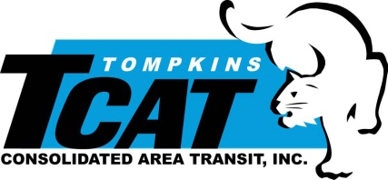
Subrecipent Information: Tompkins Consolidated Area Transit Inc. (TCAT)
737 Willow Ave, Ithaca, NY 14850

Provide documentation of service standards that TCAT has adopted. These standards are (1) vehicle load; (2) vehicle headway (3) vehicle assignment (4) service availability, (5) transit amenities and any other additional service standards, policies that TCAT in lieu of those cited may have been adopted. (see Attached: TCAT Board Resolution and Minutes).

Table 1: Transit Vehicle Loading Standards
Bus type | Seats | Max Standees | Maximum Loading Standard | Percentage of Max Capacity to Seats on Bus
20'-25' Cut-away | 16 | 6 | 20 | 125%
30' Bus/Trolley | 25 | 12 | 34 | 136%
40' Low-Floor | 38 | 28 | 59 | 150%

Table 2: Vehicle Headway (in Minutes) and Service Span Per Route Type
 | Weekday
Service Type | AM Peak | Base | PM Peak | Night | Saturday | Sunday
Urban | 30  7:00 – 9:00 | 60  9:00 – 16:00 | 30  16:00 – 18:00 | 60  18:00 – 21:30 | 60  8:00 – 22:30 | 60  9:00 – 20:30
Campus Shuttle | 15  7:30 – 10:00 | 20  10:00 – 15:45 | 20  15:45 – 18:15 | 60  18:15 – 0:30 | 60  9:00 – 2:00 | 60  9:30 – 23:00
Rural Commuter | 3 trips | 1 trip | 2 trips | 1 trip | 3 trips | 3 trips

Note: Vehicle headway and/or service span on individual routes may exceed these standards in limited situations such as where there is demonstrated ridership demand, in order to comply with TCAT’s transit vehicle loading standards, etc. Vehicle headway and/or service span on individual routes may, in limited situations, be excepted from these standards if such trips chronically perform in the bottom 5 percentile of the trips in the route category according to TCAT’s standard productivity metrics, subject to TCAT’s adopted Service Decrease and Fare Change Policy. These standards do not apply to provisional, temporary, or seasonal transit service.

Table 3: Minimum Percent On-time Service Standard
 | Schedule Frequency in Minutes
Time Period | 0 to 15 | More than 15
Peak Hours | 75% | 85%
Off-Peak Hours | 85% | 95%
Weekend | 85% | 95%

Table 4: Service Coverage/Availability Standards
Service Area Category | Max distance between stops | Min distance between stops | % transit supportive area served | % total area served | % of employers w/ >50 jobs
Urban | 1/4 mile | 400ft | >95% | >90% | >95%
Campus | 1/4 mile | 400ft | >95% | >90% | >95%
Suburban | 1/4 mile | 600ft | >95% | >75% | >90%
Village Center | 1/4 mile | 600ft | >95% | >60% | >90%
Rural | 1 mile | 1/4 mile | >95% | >10% | >85%

Passenger Amenities Policy
TCAT shall provide the following passenger amenities at all stops which are owned and maintained by TCAT:
- Identification signage
- A summary schedule of routes serving the stop with departure times
In addition to the above, TCAT shall provide the following passenger amenities at stops which are owned and maintained by TCAT and have 100 or more boarding or alighting passengers per day:
- Sheltered Waiting Area
- Bench

In addition to the above, TCAT shall provide the following passenger amenities at Stops and Stations which are owned and maintained by TCAT and have 250 or more boarding or alighting passengers per day:
- Lighting
- Trash Receptacle
- Recycling Bins

Vehicle Assignment Policy
TCAT shall assign buses to vehicle blocks with the goal of maintaining an approximately equivalent average fleet age.
Exceptions: Vehicle blocks serving low-ridership routes and/or specialized service requiring smaller vehicles, such as demand-responsive routes, may be assigned 20’ to 30’ buses.

Documentation of TCAT Board Adoption of Title VI Plan & Standards Policy
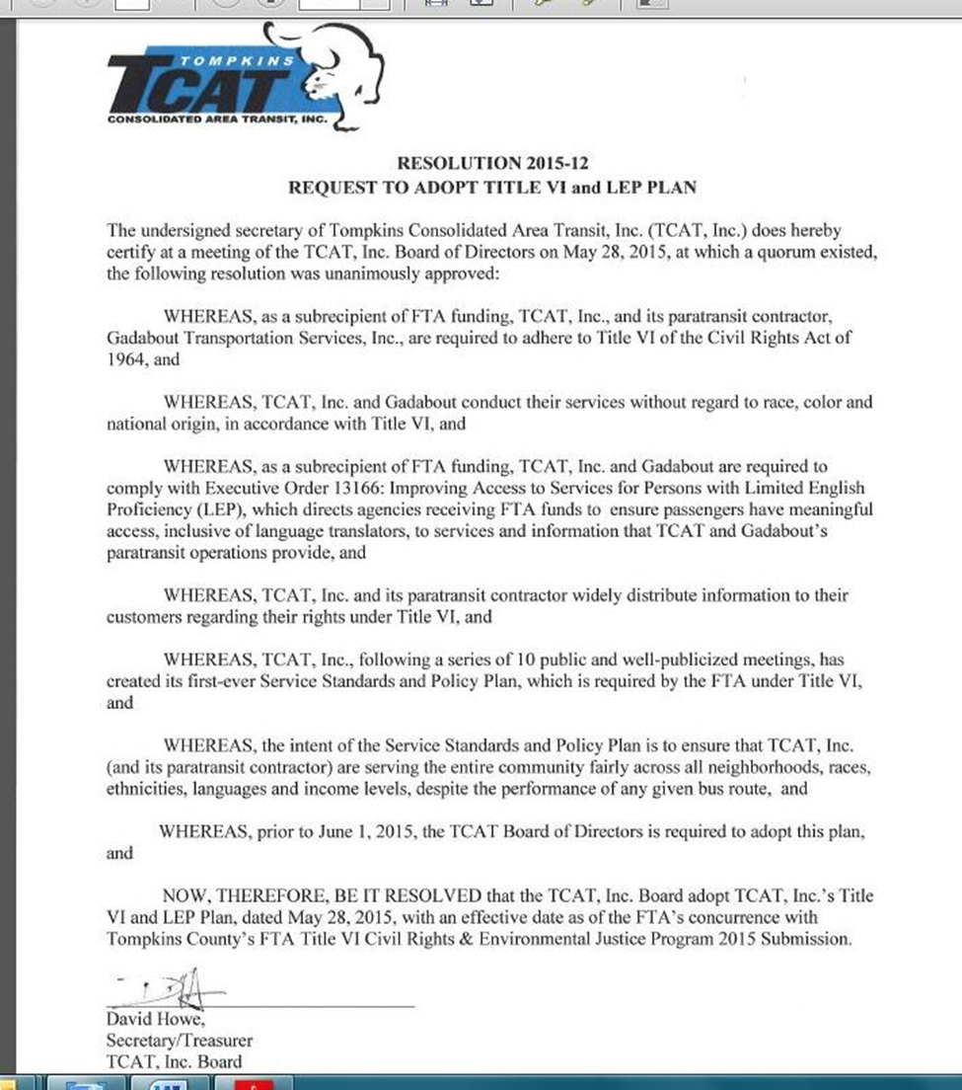

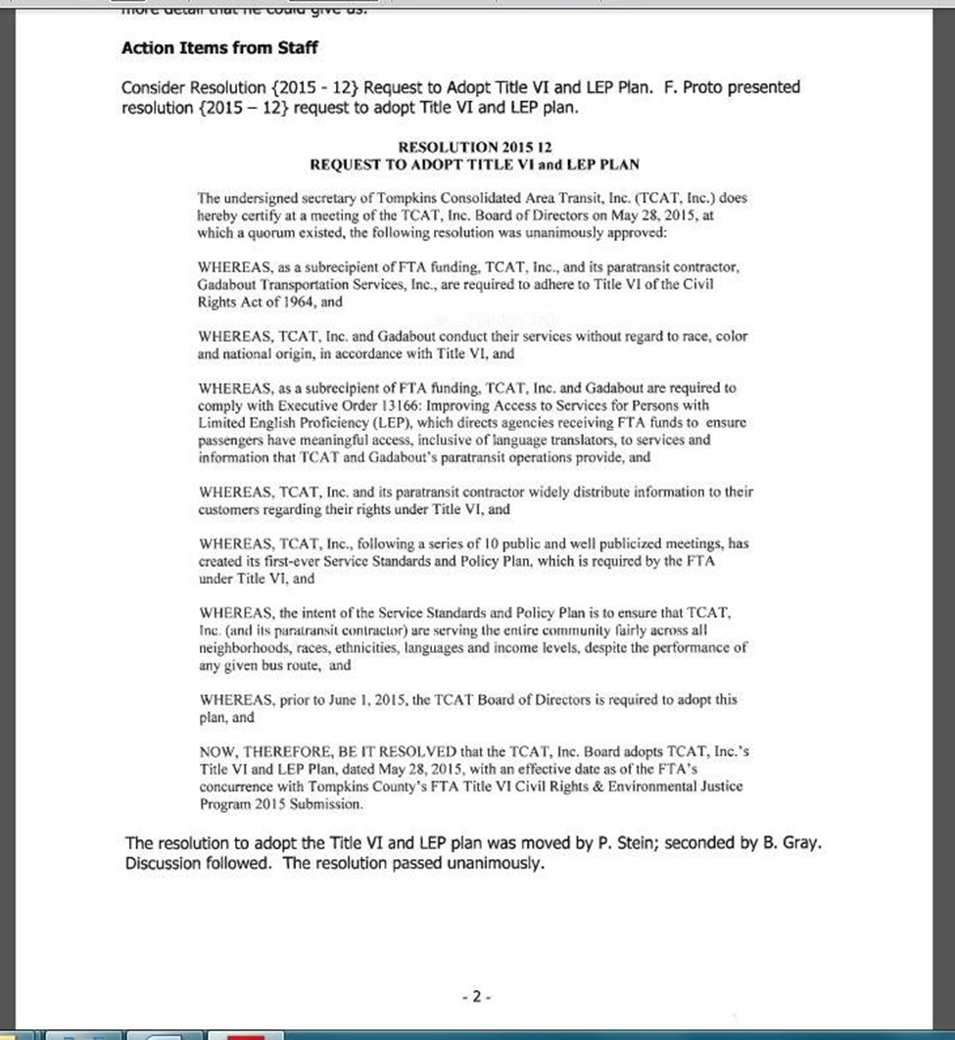

County Approval for the Title VI Program
Attach a copy of the resolution here.

