Dwight Mengel
Chief Transportation Planner
Tompkins County Department of Social Services
320 West MLK Street
Ithaca, NY 14850

Way2Go Year 5 Final Program Report
4th Contract Renewal Year
October 1, 2011 through December 31, 2012

Contents
Program Year Summary
Outreach Efforts and Impact
Project Highlights
- Senior Driver Education
- Travel Training Coordination Efforts
- Way2Go Website
- Instructional How-to Videos
- School Transportation Liaisons
- “Helping-Professionals” Educational Webinar
- Faster & Farther
- ITNEverywhere
Appendix A: Bike to Work Day Poster
Appendix B: Streets Alive! Photograph
Appendix C: National Media Coverage of Way2Go
Appendix D: Retiring from Driving Logic Model and Evaluation Tool
Appendix E: Travel Training Network Summary Sheet
Appendix F: Travel Training Strategic Planning Meeting Notes
Appendix G: ATI Newsletter Article
Appendix H:Way2Go How-to Videos (CD)
Appendix I: Transportfolio Screenshot

Program Year Summary

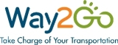
Way2Go made momentous progress this past year in reaching our overall program goals, as well as achieving several of our key objectives. Most notable for Way2Go’s fifth year was the reestablishment of the Travel Training Coordination project, significant progress in improving and expanding the Retiring from Driving project, the creation of five informational videos and refining the Way2Go website, to name a few.

Way2Go has engaged communities in new and exciting ways this past year and has focused particularly on rural communities, senior residents and those with disabilities across Tompkins County. Local residents, and even regional audiences, participated in Way2Go’s educational workshops about Retiring from Driving, Travel Training, Mobility Management and more. Through tabling at various festival and events, Way2Go made face-to-face contact with almost 2,000 more people. Tompkins Consolidated Area Transit saw nearly a 5% increase in ridership in 2012, and Way2Go strongly believes that this is in part due to outreach and tabling by local transportation stakeholders, education at workshops and through print media and the support of individuals to alter their behaviors and make the change from driving single occupancy vehicle to riding the bus. Ithaca Carshare continues to be successful in having new and interested individuals apply for membership, and Way2Go is working to make biking as a form of commuting more accepted. Bike to Work Day, which was organized for the first time in many years, had hundreds of participants from all over Tompkins County biking to work and enjoying a complimentary breakfast.
See Appendix A: Bike to Work Day Poster

Way2Go has also helped to shape the future infrastructure of Tompkins County through its work leading the ITNEverywhere project’s steering committee. From survey development and distribution to data collection and stakeholder interviews, Way2Go helped to make this project a success. Further, Way2Go will continue to facilitate the steering committee in the future, in addition to encouraging productive conversation through the Faster & Further forum.

Outreach Efforts and Impact
The following is a chart of Way2Go’s outreach efforts, along with the number of individuals reached by each activity. The following activities were implemented this year: educational workshops to the community; print advertisements; articles in local newspapers; educational videos; tabling at events and festivals. This table represents the total number of individuals that we have direct contact with at various festivals and events.

Event Name | Date | Number of People Reached
Ithaca College MLK Event | 1/24/2012 | 105
AARP Safe Driver Workshop | 2/6/12, 2/7/12, 5/21/12, 5/22/12 | 120
LACS Parent Night | 2/15/2012 | 50
Ithaca Chili Cook-Off | 2/18/2012 | 150
Get Your Green Back Launch | 2/29/2012 | 300
Training for Helping Professionals | 3/2, 9/27, 10/1, 11/14, 11/15/2012 | 45
CARS consumer workshop | 1/30, 3/16, 4/27, 6/1, 7/12, 10/26 | 60
Retiring from Driving | 2/14, 4/10, 5/30, 7/25, 8/29,9/17, 9/25, 10/17, 11/15, 12/6/2012 | 95
RFD for Caregivers | 9/13, 10/16, 11/13, 12/6 | 15
10 Days of Earth Day | 4/17/2012 | 50
WalMart Community Day | 04/28/2012 | 50
GIAC Youth Program | 5/11-5/18/2012 | 10
Community Wellness Day | 05/12/2012 | 125
Ithaca Festival | 6/1/2012 | 125
GIAC Festival | 6/9/2012 | 50
Juneteenth Festival | 6/23/2012 | 80
Apple Harvest Festival | 9/28/-9/29/2012 | 75
Puerto Rican Festival | 7/28/2012 | 65
National Night Out | 8/3/2012 | 60
Newfield Old Home Days | 9/8/2012 | 50
Senior Information Fair | 9/28/2012 | 30
Caroline School Parent Night | 9/19/2012 | 40
Enfield Harvest Festival | 9/20/2012 | 40
Streets Alive! | 9/23/2012 | 100
IC Employee Benefit Fair | 11/1/2012 | 50
Cornell Local Fair | 11/15/2012 | 35
Boynton PTA | 11/7/2012 | 15
Lifelong Bus Presentation | 11/14/2012 | 5
Tompkins Workforce | 10/21/2012 | 15
FLIC Vision Loss group | 11/19/2012 | 10
Total Direct Contacts |  | 2,020

One of the more exciting community events that Way2Go helped to organize and implement was Streets Alive!. This celebration of public space closed down Cayuga Street from the Ithaca High School to Court Street, and removed vehicles from the street and opened it up to walkers, bikers, music and more. Way2Go was in charge of coordinating a bike rodeo and distributing information about bicycle safety, as well as other logistical pieces of the festival. Way2Go worked with Cornell University’s Bike Police and Cornell University’s Bike EMS groups and reached hundreds of youth and adults. The event, which was deemed a success, will return to Ithaca in May of 2013.
See Appendix B: Streets Alive! Photograph

Way2Go also attempted to reach audiences through social media marketing efforts including Facebook and a blog. Further, Way2Go was highlighted several times in local newspapers and in a few instances, nationally. The following is a list of publications that Way2Go was in and their estimated circulation or reach.
See Appendix C: National Media Coverage of Way2Go

Media Source | Date | Number of People Reached
Human Service Coalition List Serv | 1/2/2012 | 3000
Downtown Ithaca Alliance Zimride New Years | 1/4/2012 | 2500
Facebook Zimride Post | 1/2/2012 | 110
Ithaca Carshare Zimride New Years | 1/2/2012 | 350
Way2Go homepage Zimride New Years | 1/2/2012 | 570
ICarshare homepage Zimride New years | 1/2/2012 | 500
Zimride/Carshare homepage New Years | 1/4/2012
Zimride /Carsharee-mails to IYB, GIAC, County and City employees | 1/2/2012 | 1000
Zimride New Year’s posters | 1/2/2012 | 5000
Zimride Carshare Newspaper Ad-Ithaca Times | 3/1/2012 | 15000
Zimride Carshare Ad Tompkins Weekly |  | 10000
Zimride Carshare E-mail |  | 2500
Human Service Coalition List Serv for Zimride New Years | 1/5/2012 | 3000
Zimride/Carshare e-mail to Way2Go list | 1/12/2012 | 300
Ithaca Journal article about transportation | 2/9/2012 | 17211
Ithaca Journal article about transportation |  | 17211
Chamber of Commerce Mailing | 3/8/2012 | 5000
Ithaca Journal article about transportation |  | 17211
E-mail about Senior Driver Retirement Workshops | 3/22, 3/29, 4/7 | 3000
E-mail about Senior Driver Retirement Workshops | 1x, May, June, July | 3000
Ithaca Festival Parade | 5/31/12 | 10000
Article in Ithaca Journal | 12/13/12 | 17211
Total Indirect Contacts |  | 133,674

Project Highlights
Way2Go reaches its constituents in a variety of ways. Educational workshops are held online, at senior centers, rotary clubs, community organizations, advocacy groups and businesses. Experiential learning opportunities are offered through travel training coordination and Way2Go’s how-to videos. Transportation stakeholders meet monthly under the facilitation of Way2Go in the Faster & Farther network. The Way2Go website continues to house information about all of the transportation programs and services available, as well as an online presence through Facebook and a blog. By utilizing these different mediums and outlets, Way2Go can reach a wider audience and provide them with information that is pertinent to them.

Senior Driver Education

Retiring from Driving Workshops
The Senior Driver Education workshops continue to be an identified need in Tompkins County, as shown by the NYS Independent Living Council’s Needs Assessment Survey and the Tompkins County Office for the Aging’s County-Wide Needs Assessment Survey which rank transportation in the top tier of barriers for older adults. In addition, the Tompkins County Human Services Coordinated Plan specifically identifies education to seniors as a priority project. Way2Go’s Retiring from Driving (RFD) workshop was developed to educate senior drivers on the alternative forms of transportation available to them in Tompkins County, so that they can proactively plan for a future without a vehicle. Over the past year, ten workshops were held at various locations. These were:

- 2/14/2012 at Lifelong Learning
- 4/10/2012 at the Lansing Public Library
- 5/30/2012 at the Newfield Garden Apartments
- 7/25/2012 at Lifelong Learning
- 8/29/2012 at the McGraw House
- 9/17/2012 at Lifelong Learning
- 9/25/2012 at Titus Towers
- 10/17/2012 at Lifelong Learning
- 11/15/2012 at Lifelong Learning
- 12/6/2012 at Lifelong Learning

Surveys administered after the workshops found that:
- 85% of participants felt that the workshop was worthwhile and informative
- 90% of participants felt that the presenter was effective
Other comments were:
- “The presenters explained the information clearly and kindly answered all questions asked.”
- “I learned about 2-1-1 and FISH.”
- “I can recognize my own resistance to change.”

Retiring from Driving: A resource for caregivers
Way2Go also began working with the Community Dispute and Resolution Center (CDRC) to build a program for family members and caregivers about senior driver retirement. These workshops educated individuals about the various forms of transportation programs and services, and gave them tools to use to facilitate a conversation with family members. Specifically, mediation skills were built through printed materials, role-playing and active listening activities. This project began in August of 2012 and was held five times in the community between August and December. These retiring from driving workshops for caregivers were held at:
- 9/13/2012 at Lifelong Learning
- 10/16/2012 at the Groton Public Library
- 10/29/2012 at the McGraw House
- 11/13/2012 at Lifelong Learning
- 12/6/2012 at the Tompkins County Public Library

Surveys were administered after the workshops and found that:
- 80% of participants felt that the mediation skills learned were very valuable
- 85% of participants felt that the trainers were effective in communicating information
Other comments were:
- “I learned a different way to approach the conversation and to listen more.”
- “I was shocked at the wealth of information provided.”

Way2Go and the CDRC have been meeting to plan the transition of the Retiring from Driving workshop for caregivers from an in-person workshop to a recorded webinar, so that caregivers can view it when they need the information. Way2Go and CDRC will still be available to meet with families individually if they would like more information.

Way2Go was approached by the Cornell Institute of Public Affairs (CIPA) professor, Dr. Margaret Johnson, in the fall. Dr. Johnson offered the assistance of a group of her graduate level students, who were studying the application of logic models and evaluations practices in non-profit and government organizations. The group of students worked to develop and refine a logic model for the Retiring from Driving project, and also created a new evaluation tool for distribution at workshops. These new, shorter, surveys are meant to help collect the information that Way2Go needs to determine measurable impacts for the project to gauge success and what information participants are learning.
See Appendix D: Retiring from Driving Logic Model and Evaluation Tool

Travel Training Coordination Efforts

Travel Training Network
Way2go convened the Travel Training Network on June 25, 2012 to identify needs, coordinate local travel training services, share best practices, and plan projects to improve travel training services in Tompkins County. The network consists of agencies that provide services to individuals that face significant mobility challenges. Thirty-eight professionals from local and regional agencies receive regular updates on the activities of the travel training network. From June to December, the travel training network met five times. Way2Go hosts a webpage that contains resources and tools for local travel trainers, and a hub for the travel training network. The webpage averaged 91 page views a month between August 2012 and January 2013.
The following agencies have participated in the Travel Training Network:
- The Finger Lakes Independence Center
- Franziska Racker Centers
- Department of Social Services
- TCAT
- Tompkins County Office for the Aging
- Challenge, Inc.
- Unity House
- Lakeview Mental Health
- Cornell Cooperative Extension of Tompkins County
- TST BOCES Special Education Program
- Cornell Diversity and Inclusion Department
- Broome-Tioga Mobility Management Project
- Tompkins Learning Partners
See Appendix E: Travel Training Network Summary Sheet
Travel Training Survey
In August, Way2Go conducted a survey of 18 staff from 14 agencies serving individuals with mobility barriers to identify common needs, resources and priority projects for the network. The survey found that among these agencies, the full spectrum of travel training services is provided. Some agencies provide basic information to consumers about what transportation options are available in the region while other agencies work one-on-one with individuals to develop their skills and knowledge so that they can travel independently. Further conversations found that one-on-one travel training services are provided informally within organizations by staff without professional training in travel training methods. Only one agency, Challenge Inc., formally offers travel training to its clients and has staff members that have received training in professional travel training methods. Further, one-on-one travel training services are only available to clients enrolled in agency programs.
The survey asked agencies to select three priority projects that they believe will increase access to transportation through improvement of travel training services. 14 survey respondents (78%) selected a central travel training program as a high priority project that would improve access to transportation in the county. The program would be open to all individuals that request one on one travel training and take referrals from other agencies.
Introduction to Travel Training Workshop
Way2Go hosted Chris Hunter to conduct a daylong introduction to travel training workshop on November 29 to facilitate professional development. Chris Hunter has eight years of experience travel training and works with Easter Seals Project Action to conduct introductory travel training workshop across the United States. 15 people attended the day long introduction to travel training workshop and represented individuals from disability services, vocational services, education, and mobility management.
In the evaluation, all of the participants rated the presentation style and presenter’s knowledge of travel training either good or excellent. Most the attendees will now use a more thorough client assessment when they travel train. Attendees also increased their knowledge of emergency planning in travel training was particularly useful.

Travel Training Strategic Planning Meeting
The strategic planning meeting brought together 24 decision makers from transit, mental health, vocation, education, immigrant services, and disability services. Chris Hunter facilitated the meeting and used his experience as a travel trainer to help inform the audience and answer questions. Attendees were educated about travel training and identified action steps for improving travel training in Tompkins County. The following action steps were outlined at the meetings:
- Travel training program design. Chris Hunter suggested that travel training is most effective when a central agency provides travel training services. This avoids a duplication of services and efforts.
- Coordination between travel training programs and agencies that provide service to target populations
- Identifying an appropriate host agency and location to house a central travel training program
- Securing funding to sustainably fund a full time travel trainer
The meeting concluded with the formation of two committees consisting of attendees from the meeting. The program committee will develop a business plan for a travel training program in Tompkins County. The funding committee will take the lead on searching for funding for the travel training program. The attendees agreed to reconvene in January. The strategic planning meeting brought together stakeholders from:
- Cornell University Student Disability Services
- Cornell Cooperative Extension of Tompkins County
- Tompkins County Mental Health Services
- Finger Lakes Independence Center
- Tompkins Consolidated Area Transit (TCAT)
- Gadabout
- Tompkins Workforce
- Challenge, Inc.
- Tompkins Learning Partners
- Tompkins County Office for the Aging
- TST BOCES Special Education Program
- TST BOCES Community School
- Franzicka Racker Centers
- Tompkins County Department of Social Services
- Lakeview Mental Health Services
- Broome-Tioga Mobility Management Project
- Tompkins County Long Term Care Program
See Appendix F: Travel Training Strategic Planning Meeting Notes

Transit Orientation & Familiarization
Way2Go is working with agencies serving older adults to conduct transit orientation and familiarization targeted for older adults. A survey of Longview residents conducted by Longview staff showed that residents are not taking advantage of the bus because they are not sure how to access it or are intimidated by it. Longview and Way2Go collaborated on a two-session transit orientation course. The first session was an hour-long presentation to twenty senior residents about how to use the transit system. Topics covered in the presentation included bus map and schedule reading, paying fare, how to get to popular destinations, and safe bus riding tips.
The second session was a field trip on the bus to a shop in downtown Ithaca that was limited to six residents. TCAT supported the field trip with one-day passes for the residents. The participants were not regular participants fixed route bus and expressed interest in continuing to ride TCAT after our session. Way2Go and Longview will continue to collaborate to offer transit orientation to residents of Longview.
Way2Go is also working with Lifelong to expand its transit orientation and familiarization effort to other senior housing agencies. The “Bus(T) a Move” program is targeted to older adults who want to learn more about riding the bus. Lifelong incorporated the program into its Spring catalog and set up four presentations at senior housing agencies around Tompkins County. The program is planned to launch in February 2013.
Rural Travel Training Phone Conference
Way2Go founded and co-organized a national phone conference on rural travel training with the Association for Travel Instruction (ATI). The phone conference was developed to highlight issues and best practices for travel training in rural regions. 12 professional travel trainers participated in the hour long phone conference and variety of topics were discussed such as collecting data on outcomes of mobility training, funding of travel training services, strategies for training ESL populations, and physical access to bus stops. This was the first phone conference hosted by ATI, and the association plans to continue to host regular phone conferences on topics related to travel training.
See Appendix G: ATI Newsletter Article
Way2Go Website

The Way2Go website, www.Way2Go.org, continues to see heavy traffic. During 2012, there were 16,401 views on the website and 4,826 unique views. The most heavily visited pages on the website were:
- Retiring from Driving with 1,673 visitors
- Travel Training with 518 visitors
- Bus and Paratransit with 476 visitors
- Carshare and Vanpool with 441 visitors
- Medical Transportation with 377 visitors
Updates to the Website
Way2Go updates the website with new information as it becomes available, and has contact information for resources in and out of the county. We added the Transportfolio for the helping professionals’ workshop/webinar to the website so that it can be as needed and updated easily. The website now houses the Way2Go how-to videos, which have seen high traffic. The layout for the website has changed slightly, with the photographs throughout the site now replaced with local pictures, as opposed to the stock pictures in the past. In addition, Way2Go created the Travel Training page, which includes information about travel training services in Tompkins County, as well as minutes from the Travel Training Network and a list of past and upcoming meeting dates and locations.

Way2Go also continues to have a presence on Facebook, which had 157 followers. The Facebook page updates followers on transportation service changes, current promotions and fun facts about transportation from Tompkins County and beyond.

Instructional How-to Videos
One of the most exciting projects completed this year were the instructional how-to videos on Tompkins County transportation services. These videos, produced by Moving Box Studios, had scripts written by Way2Go and focused on:
- TCAT: Bus Basics - A video that shows the basics to using the public transit system
- TCAT: Bike on Bus – How to load and unload your bike on the TCAT Buses
- TCAT and Gadabout: Wheelchair on Bus – How to board the TCAT bus or Gadabout bus with a power chair or wheelchair
- Ithaca Carshare: Basics – A introduction to Ithaca Carshare, and how to apply for membership
- Ridesharing: How and Why – An explanation of what services are available to assist people interested in ridesharing

Since being posted online in December of 2012, these videos have been viewed nearly 900 times, with the Wheelchair on Bus and Bus Basics being viewed the most.
See Appendix H: Way2Go How-To Videos CD

Work with Schools

Educational Outreach in the Schools
Way2Go worked collaboratively with the volunteer Coordinator of the School Success Transportation Coalition (SSTC), and provided training and support to transportation liaisons in the Ithaca City School District. On average, liaisons have been active in over 90% of ICSD’s twelve schools, sharing transportation information in via newsletters, email lists and other communication outlets. At least 10 families were provided information or assistance directly including:
- Referrals to taxi rides provided by the school district
- Successful support in finding a shared ride
- Referral to Ithaca Carshare
- Assistance by several administrators to find a ride to play rehearsal for a student
- Referrals to RED volunteer drivers in order to attend a disciplinary meeting, read to a grandchild’s class, etc.
In order to promote institutional transportation solutions, and to foster a ridesharing culture in the schools, we also met with ICSD school administrators and Parent/Caregiver and Parent-Teacher Associations. Activities and outcomes include:
- 2/15/2012: Presentation to over 35 staff at LACS staff meeting.
- 2/15 and 9/24: Way2Go-led presentation, dialog and information display at the Lehman Alternative Community School State of the School parents’ night.
- 4/30 and 10/22: Meeting between Superintendent Dr. Brown, members of SSTC, and school liaisons, leading to a LACS shuttle being utilized in a new way to solve a transportation gap. At a follow up meeting with Dr. Brown, the Superintendent was enthusiastic about integrating ridesharing support into the upcoming new ICSD website.
- 9/18: Presentation on transportation issues and ridesharing to around 40 ICSD Principals, Assistant Principals and Senior Staff members.
- September through November, 2012: Led discussions at Caroline Curriculum night, and with the Enfield PTA, LACS Parent-Caregiver Group, BJM PTA, and Boynton PTA.
As a result of the above actions, Caroline is considering incentivizing ridesharing among afterschool enrichment program participants, LACS is working on a geographically-based directory of school families to facilitate potential shared rides; and Enfield PTA considering using their FaceBook page as a place where parents and caregivers can post ride offers and requests.
“Helping Professionals” Workshop and Educational Webinar

Training and Outreach
Way2Go continued to provide educational training and outreach to helping professionals, providing them with the information they need to assist high priority transportation consumers in making the best use of existing transportation resources. We produced a revised Transportfolio binder of transportation information was produced, which was distributed to over 125 helping professionals, including staff members of:
- Ithaca City School District school nurses’ offices
- Cayuga Medical Center
- Ithaca Youth Bureau
- County Health Department
- Tompkins Learning Partners
- Catholic Charities
- Town of Ithaca Sustainability Planning office
- Department of Social Services staff
- Several transportation service providers
- Tompkins Community Action
Virtually the entire Transportfolio was also made available online, with some helping professionals preferring to access it’s content via the Way2Go website. A new round of in-person training for helping professionals was held on March 2 for 15 participants representing over a dozen different organizations. Way2Go’s first live webinar training for Helping Professionals was held on September 27, with three new participants attending in person, and ten participants attending remotely.
The 2 1/2 hour training included guest presentations from Ithaca Carshare, the Department of Social Services and Way2Go Travel Training Coordinator, as well as a “tour” of Way2Go’s comprehensive binder of transportation information, available in hardcopy or online. The WebEx webinar interface was effective in sharing information, interacting with participants, and enabling presentations by panelist from multiple locations. Although our audience was modest, participant evaluations were overwhelmingly positive in terms of the quality of the webinar and the usefulness of the content.
Looking ahead, Way2Go will be making the recordings of the webinar available to be viewed remotely anytime. We will be holding both in-person and web-based trainings in the upcoming year.
See Appendix I: Transportfolio Screen Shot

Faster & Farther

Leading the Network
Way2Go continued to lead the Faster & Farther Network of transportation-related professionals (F&F), convening 10 meetings and organizing agenda items, presentations and guest speakers. In addition to the fulfilling the core mission of networking, sharing updates and relationship building among members, F&F activities included:
- Support for collaborative, multi-modal marketing, outreach materials, and information tabling. One example of this was TCAT’s inclusion of several pages of additional transportation information in their relatively new route guide.
- Feedback on Way2Go’s educational materials and annual plan
- A Way2Go-led presentation and dialog on mobility mapping—what it is, what has been done elsewhere and why we might want to do it here.
- Discussion of and feedback on Downtown Ithaca Alliance’s Strategic Plan
- Presentation by Josh Lower, Developer of Collegetown Crossing: Car-Free Living housing project, leading to an increased public showing of support.
- Support for creation of and administration of Community Transportation Fund.
- Discussion of the City of Ithaca’s $4.5 million FTA's State of Good Repair Grant for improvements and upgrades to the Ithaca Commons and transit services.
- Feedback and several new items contributed to the Tompkins Co. Strategic Tourism Plan.
- Collaboration between members on Way2Go’s how-to transportation videos.
- Submissions to Get Your Green Back’s (GYGB) guidebook transportation section, and generation of video contest idea for Jan. Transportation Month.
- Help with other transportation-related event-planning, such as Streets Alive!
Looking ahead, Way2Go will be leading Faster & Farther (F&F) in taking a new look early in 2013 at F&F’s purpose, structure and goals. We also expect to be creating an online presence and increased electronic communications for F&F in the New Year.
ITNEverywhere
Research and Development Project
Way2Go staff served as local coordinator of the ITN Everywhere (ITNE) research and development project and liaison to the ITNE staff. We assembled a local Steering Committee and an Advisory Group of transportation providers, facilitating both remote and in-person meetings with the ITNE staff. In addition, the group:
- Managed the ITNE site visit on March 21-22, coordinating efforts to assemble two large, diverse and successful focus groups of drivers and non-drivers.
- Arranged over a dozen in-person and remote interviews between the ITNE staff and diverse community leaders with a stake in transportation.
- Coordinated the finalizing, distribution and data collection of a community-wide survey on people’s transportation needs and receptiveness to new models of service, resulting in an unprecedented level of participation with 731 respondents.
- Arranged in-depth software feedback interviews during ITNE’s July visit, including members of the public and two Steering Committee members.
- Exercised diplomatic pressure and persistence in securing the Landscape Survey final report from ITNE staff.
In addition to helping determine any future use of ITNE software products, a version of the Landscape Survey Final Report will be made public. Among other uses, it will help inform a Regional Transportation Study. Although the ITNE Project is completed, the former Steering Committee continues to meet, and will use the data and momentum of the project to consider, research, prioritize and take steps toward one or more transportation service innovations or improvements.

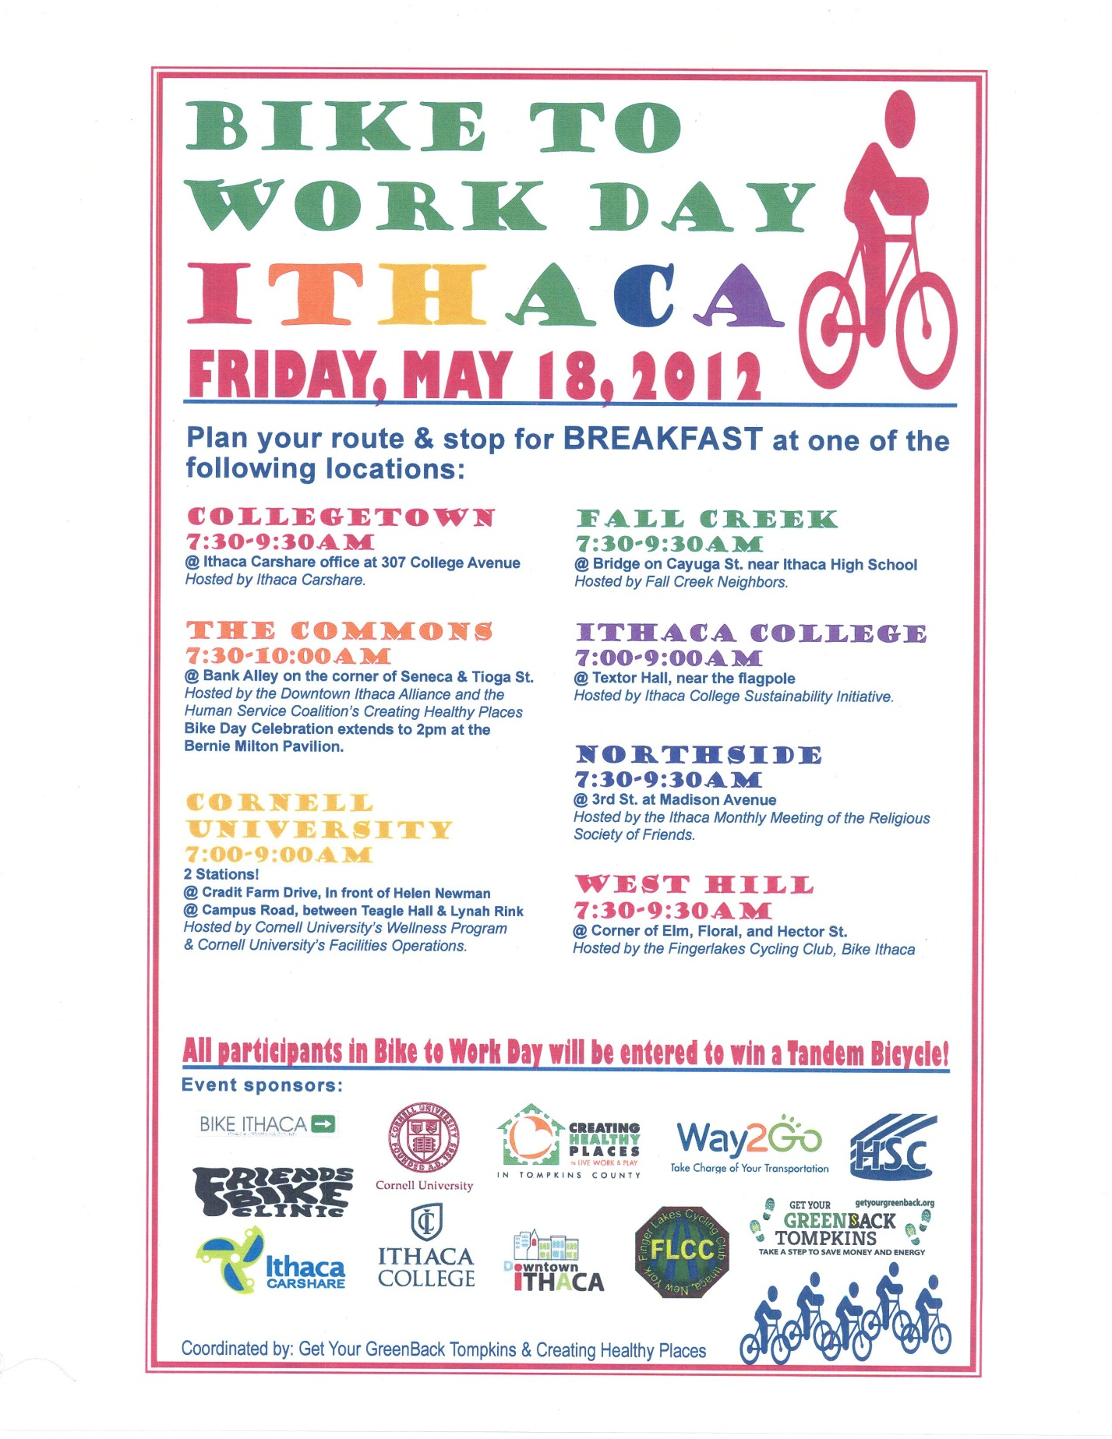
Appendix A. Bike to Work Day Poster
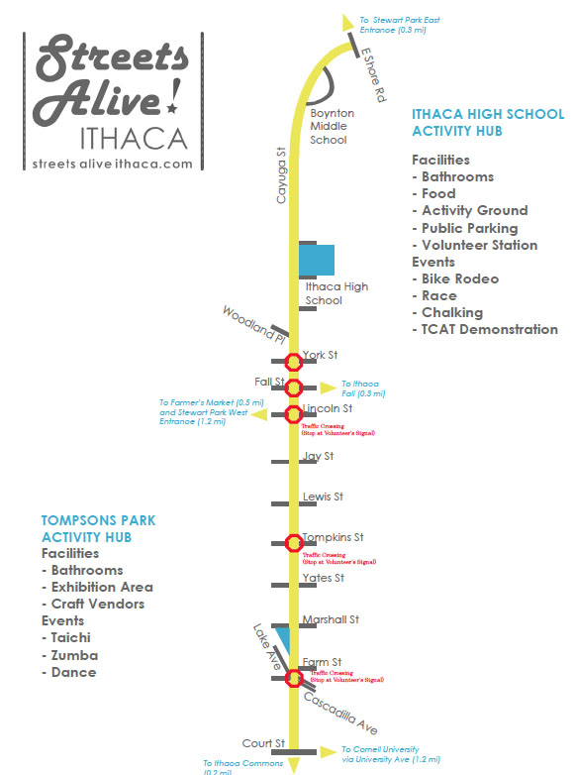
Appendix B. Streets Alive! Event Map
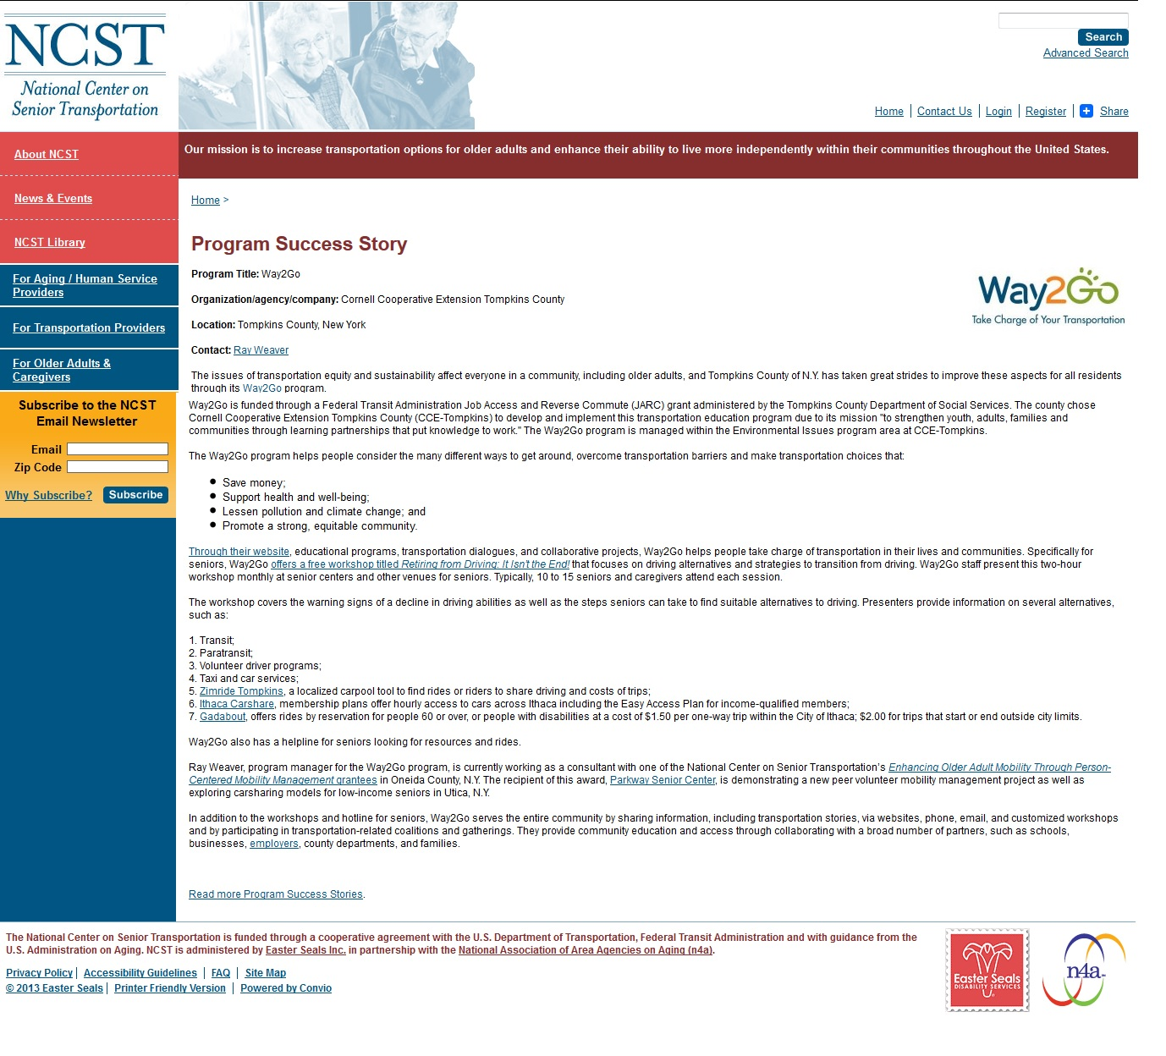

Appendix C. NCST Coverage of Way2Go

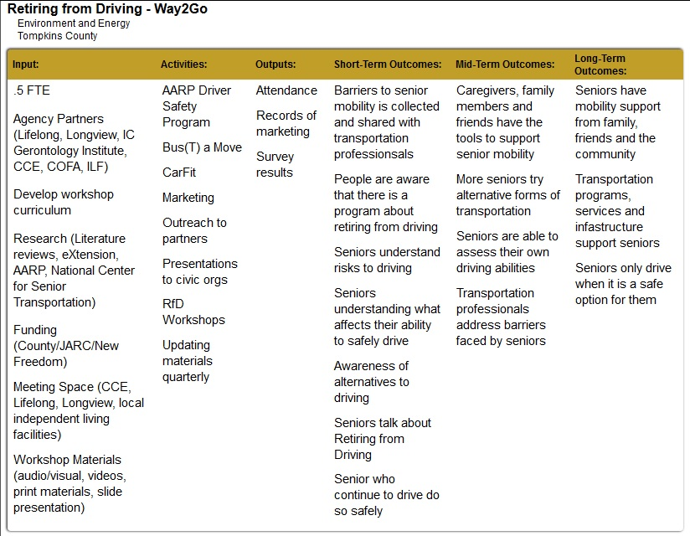
Appendix D. Retiring from Driving Logic Model

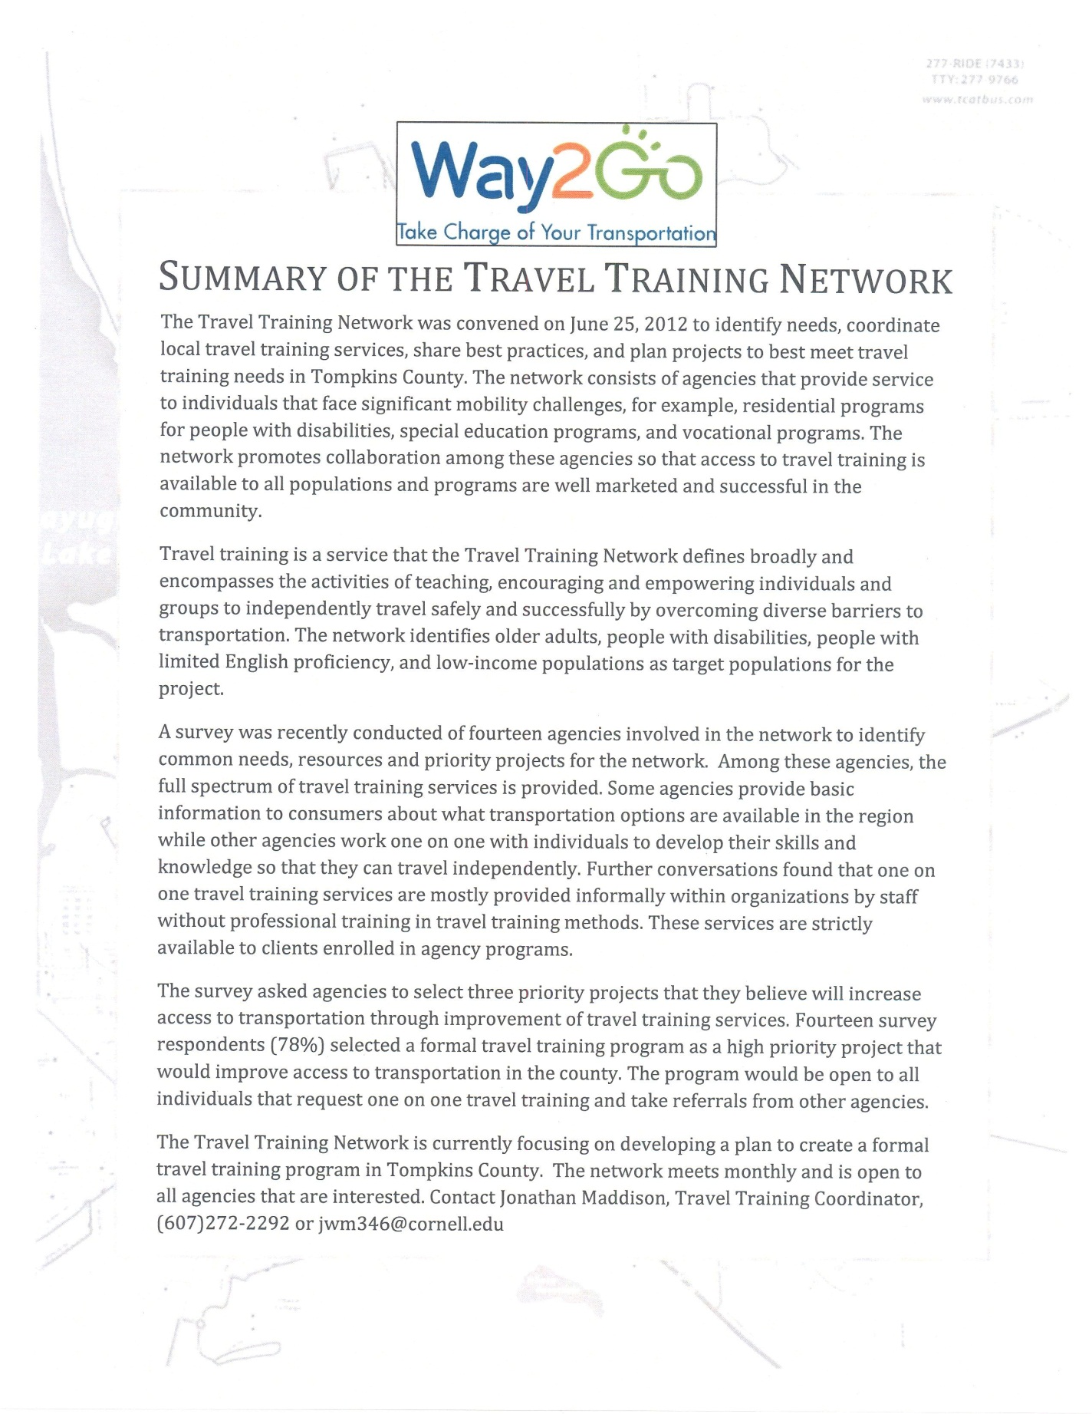
Appendix E. Travel Training Poster
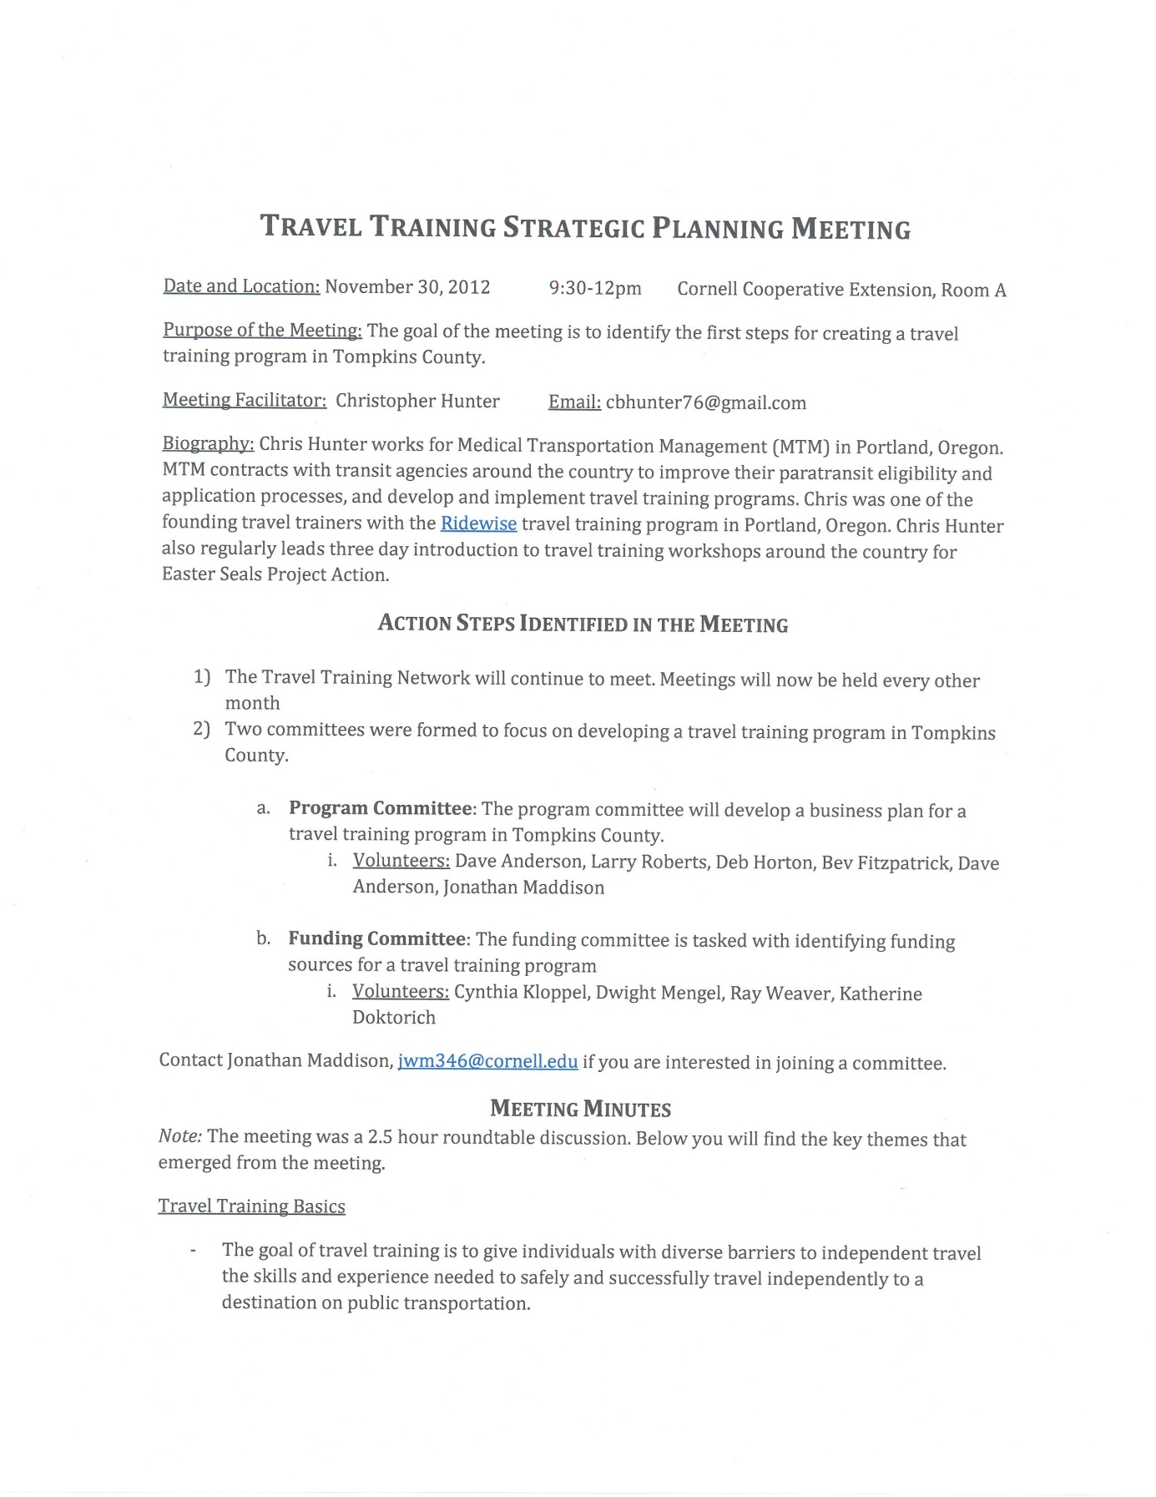Appendix F. Travel Training Strategic Meeting Notes, pp 19-21.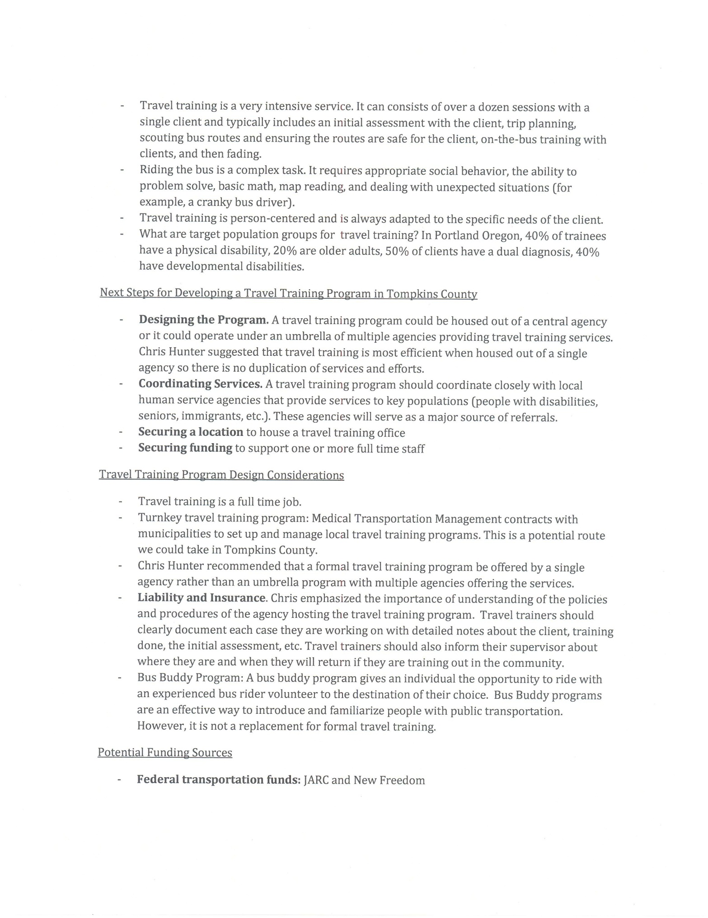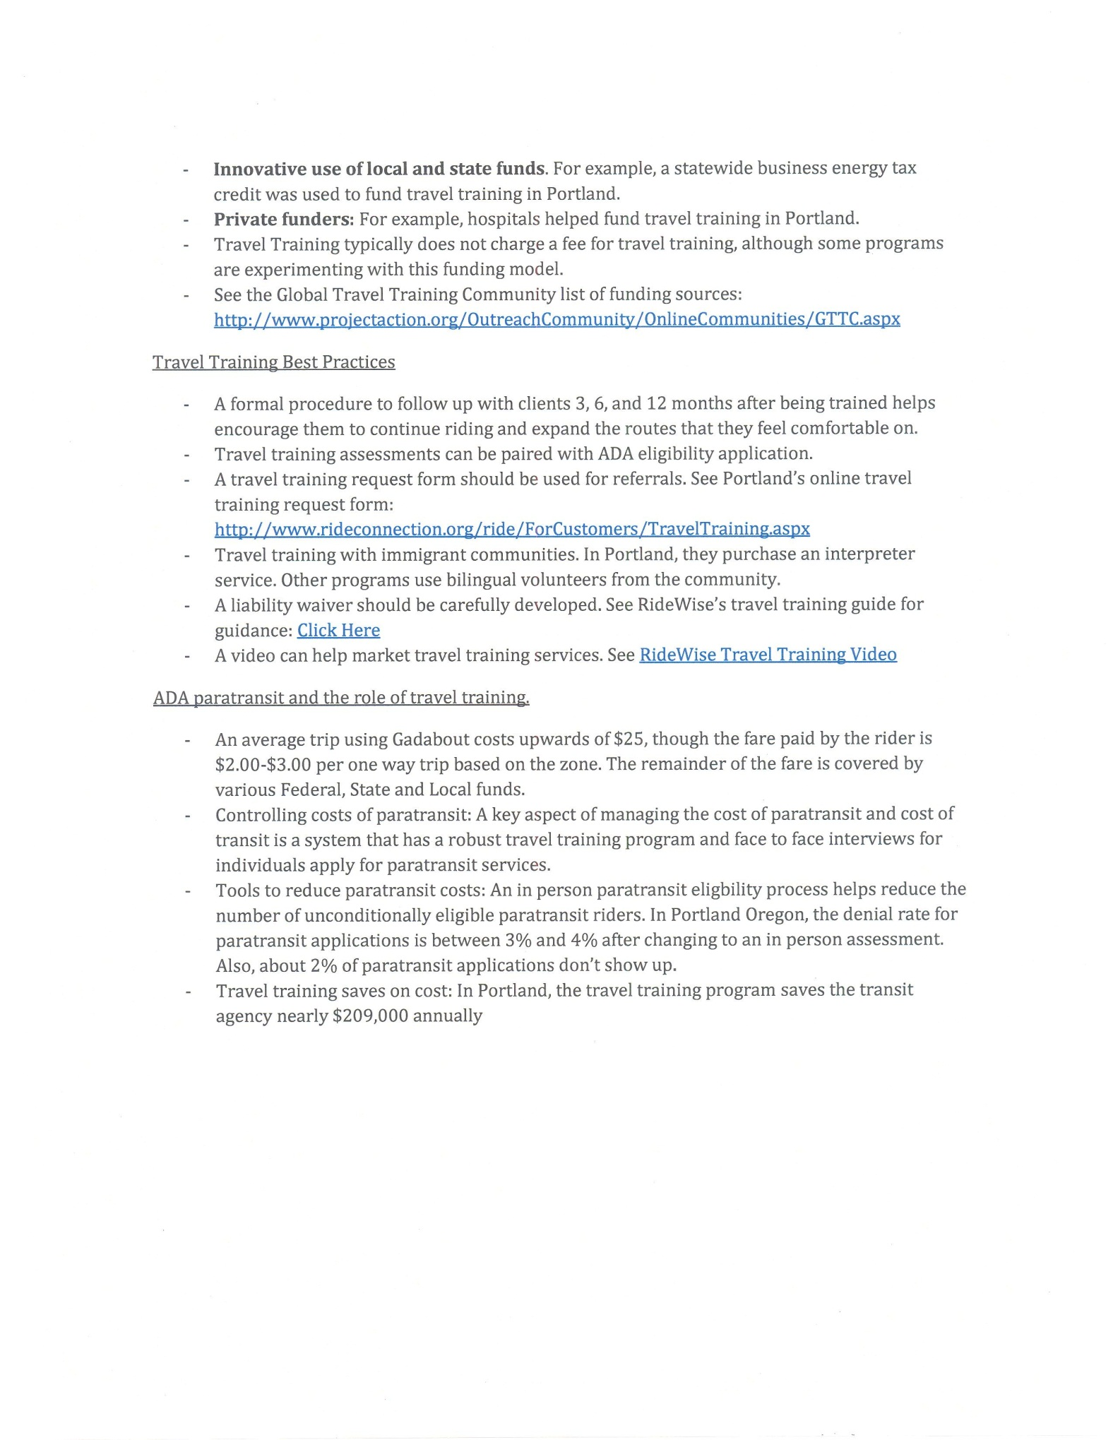
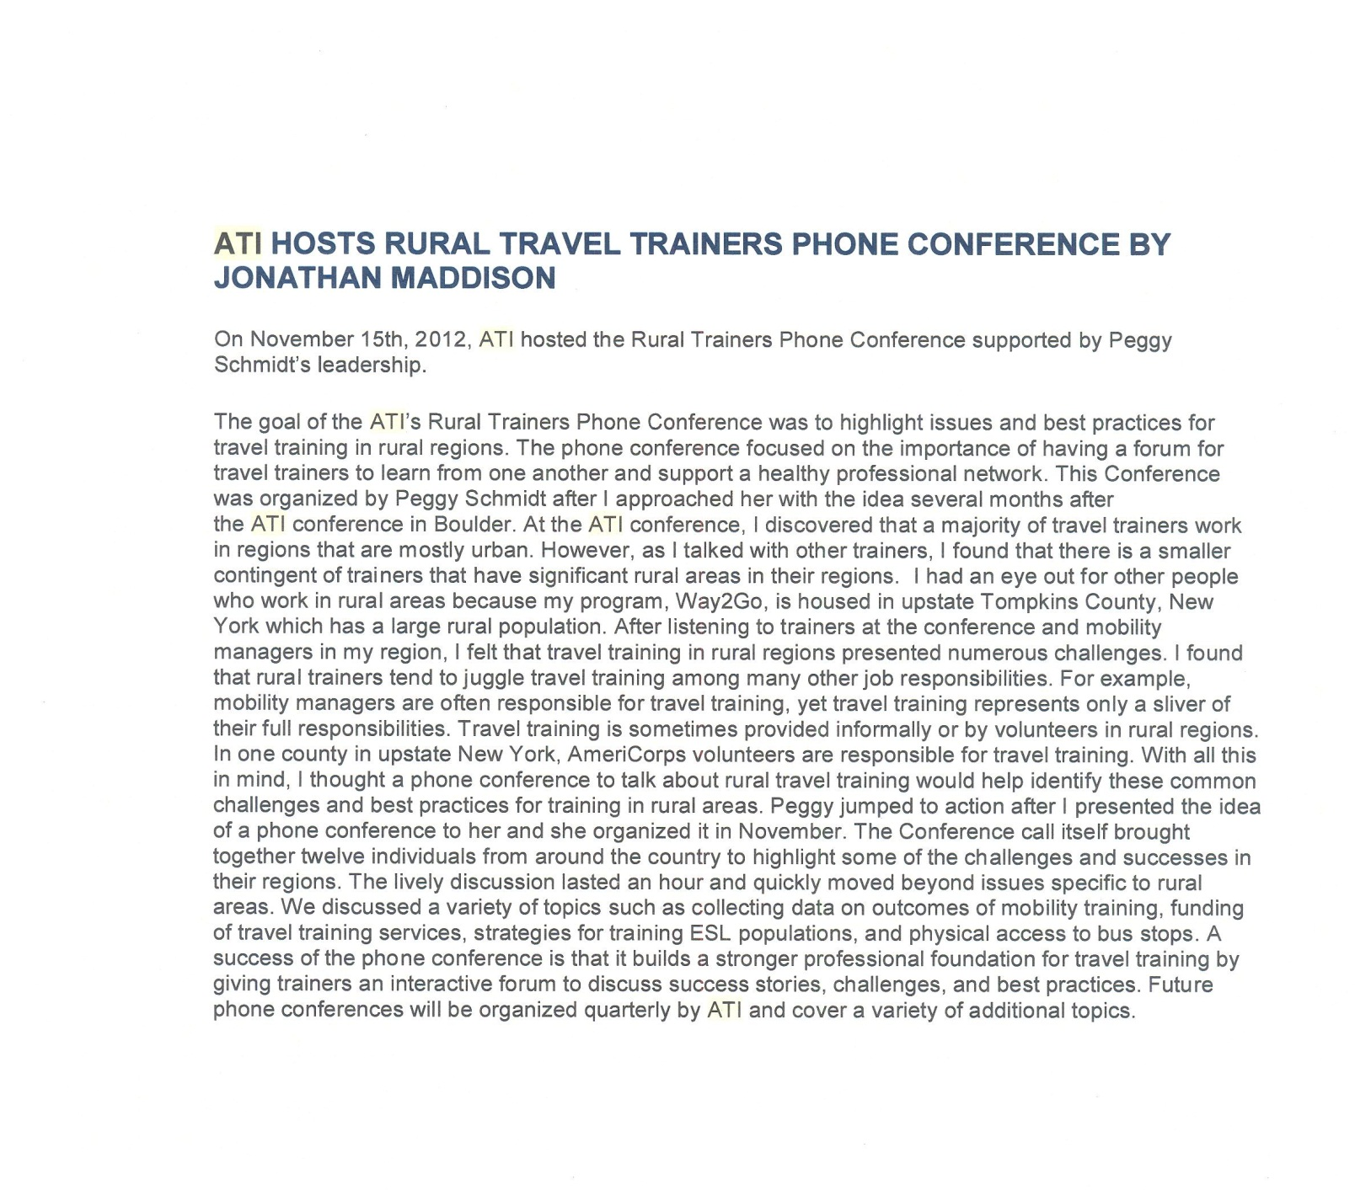
Appendix G. ATI Newsletter Article on Travel Training Phone Conference

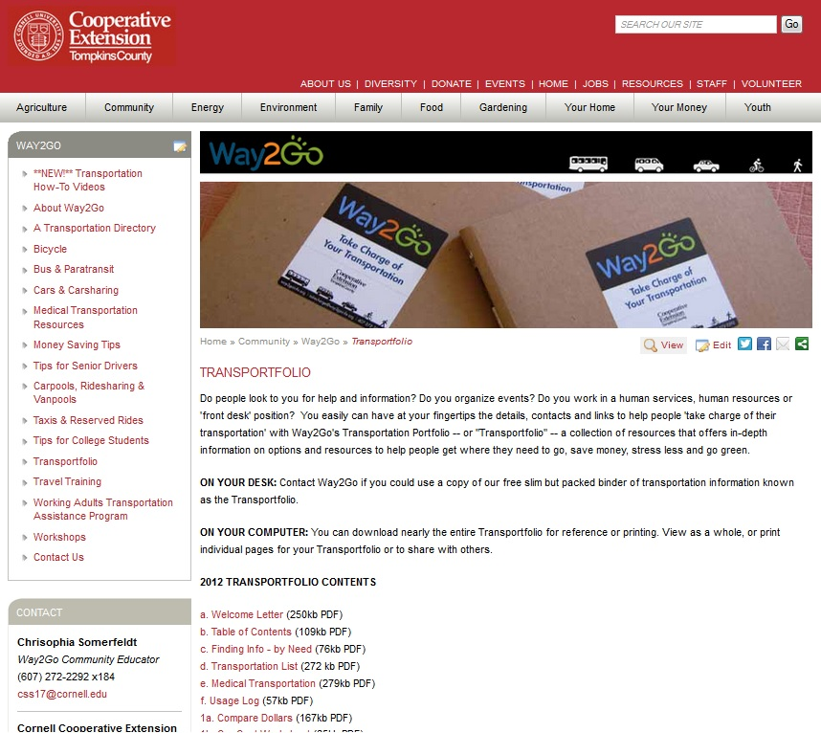

Appendix I – Transportfolio Screenshot

